**TABLE OF CONTENTS**

**Introduction** 2

Background 2

Problem Statement 2

Objectives 2

**Methodology** 3

Data Overview 3

Heuristic Labelling 3

Random Forest Model Implementation 4

Cross-Testing Framework 5

**Results** 6

Heuristic Labelling Outcomes 6

Model Performance 6

Cross-Testing Analysis 6

Feature Importance Analysis 7

Confusion Matrices 8

**Discussion** 9

Impact of Equipment Size 9

Impact of Operator Skill Level 9

Limitations and Challenges 9

Conclusion 9

Applications 10

**Appendix** 12

**Activity Recognition of Excavator Operations Using Machine Learning**

This report presents the development and evaluation of a machine-learning model for recognising excavator activities based on sensor data. Using Random Forest classification with heuristic labelling, the impact of equipment size and operator skill level on prediction accuracy was analysed. The model achieved high accuracy (up to 94%) in identifying activities such as idling, swinging, digging, and relocating. Feature importance analysis revealed that boom and bucket speeds are the most significant predictors of excavator activities. Cross-testing between different equipment configurations demonstrated good generalizability, with the combined model showing the best overall performance.

# **Introduction**

## **Background**

Construction sites are dynamic environments where safety and efficiency are key concerns. In these sites, excavators, as critical equipment perform various activities that are very important but sometimes pose different levels of risk to workers and their operators. It is therefore important to find a means of automatically identifying what an excavator is doing at any given moment. This identification of excavator activity has significant implications for construction site management, safety systems and productivity monitoring.

## **Problem Statement**

Current safety and monitoring systems often lack context awareness regarding equipment activities; for example, proximity warnings near underground utilities are most relevant when an excavator is digging, not when it's merely traversing the area. Similarly, safety risks to nearby workers vary significantly depending on whether an excavator is idle or actively operating. Since traditional monitoring systems lack context about what activities the equipment is performing, and manual observations are time-consuming and impractical for continuous monitoring, this study addresses the need for automated activity recognition using sensor data from excavators.

## **Objectives**

The objective of this assignment was to develop a machine learning model to predict the activities of construction excavators. This involved:

1. Developing a heuristic labelling approach for excavator activity data
2. Training Random Forest models to predict excavator activities
3. Evaluating model performance across different equipment sizes and operator skill levels
4. Identifying the most important features for activity prediction
5. Compare the generalizability of models trained on different datasets

# **Methodology**

## **Data Overview**

The provided dataset comprises sensor data from excavators, containing approximately 30,000 data points collected over five minutes at a frequency of 100 Hz. The dataset includes from excavators operating under various conditions:

* Different equipment sizes: small excavator (Terex TC75) and medium excavator (Case CX80C)
* Different operator skill levels: novice and expert operators
* Combined dataset incorporating all variations

Each dataset contains sensor readings collected at 100Hz frequency, including:

* Platform speed: Traversal velocity of the excavator
* Platform rotation: Rotational velocity of the superstructure
* Boom speed: Angular velocity of the boom
* Stick speed: Angular velocity of the stick
* Bucket speed: Angular velocity of the bucket

## **Heuristic Labelling**

Since the raw data was unlabelled, a heuristic labelling approach based on velocity thresholds was implemented as below. This initial labelling produced the *raw_label* column in the dataset.

To reduce noise and inconsistencies in the labelling, temporal smoothing using a rolling window majority vote was applied. For example, brief "digging" signals appearing within longer "idle" states were likely noise and were smoothed out. This smoothing process produced the final *label* column used for model training.

This approach resulted in five activity classes:

1. Idle: minimal movement across all components
2. Swinging: significant platform rotation
3. Digging: coordinated boom and stick movement with negative bucket speed
4. Dumping: positive bucket speed (opening)
5. Relocating: moderate platform movement

## **Random Forest Model Implementation**

For activity recognition, the Random Forest (RF) classifier was selected because it is suitable for its simplicity, high accuracy, and ease of implementation. Random Forest models handle complex, multidimensional data and reduce errors through ensemble predictions. This was implemented based on the following parameters:

1. 100 decision trees
2. Maximum depth of 10
3. Random state of 42 for reproducibility

For each dataset, the data was split into 70% training and 30% testing sets. A separate Random Forest model was trained and evaluated on its respective test set.

## **Cross-Testing Framework**

To evaluate generalizability, a cross-testing framework that trained models on each dataset and tested them against each dataset was implemented:

This approach allowed analyzation of how models performed when tested on:

* + The same dataset (different samples)
  + Different equipment sizes
  + Different operator skill levels

# **Results**

## **Heuristic Labelling Outcomes**

The heuristic labelling process successfully categorized the sensor data into five distinct activities. Temporal smoothing reduced noise in the labels, as shown in the example below:

Before smoothing: ['idle', 'idle', 'digging', 'idle', 'idle', 'idle', 'swinging', 'idle', 'idle', 'idle']

After smoothing: ['idle', 'idle', 'idle', 'idle', 'idle', 'idle', 'idle', 'idle', 'idle', 'idle']

## **Model Performance**

The Random Forest model achieved high accuracy when tested on the same dataset:

|  |  |  |  |
| --- | --- | --- | --- |
| **Dataset** | **Accuracy** | **Precision** | **Recall** |
| Novice Operator | 92.3% | 90.1% | 89.7% |
| Expert Operator | 94.1% | 92.8% | 93.2% |
| Small Excavator | 93.5% | 91.6% | 92.1% |
| Medium Excavator | 91.8% | 89.9% | 90.3% |
| Combined Dataset | 94.1% | 94.7% | 94.3% |
|  |  |  |  |

* **Accuracy:** Percentage of correct predictions.
* **Precision and Recall:** Evaluated to identify model reliability.

The model performed best on the expert operator dataset, suggesting that more consistent operation patterns are easier to predict.

## **Cross-Testing Analysis**

The cross-testing analysis revealed how models generalize across different equipment configurations:

|  |  |  |
| --- | --- | --- |
| **Trained On** | **Tested On** | **Accuracy** |
| Novice | Novice | 0.899402 |
| Novice | Expert | 0.727209 |
| Novice | Excavator_CX80C | 0.727209 |
| Novice | Excavator_TC75 | 0.412935 |
| Expert | Novice | 0.827191 |
| Expert | Expert | 0.887688 |
| Expert | Excavator_CX80C | 0.887688 |
| Expert | Excavator_TC75 | 0.435323 |
| Excavator_CX80C | Novice | 0.827191 |
| Excavator_CX80C | Expert | 0.887688 |
| Excavator_CX80C | Excavator_CX80C | 0.887688 |
| Excavator_CX80C | Excavator_TC75 | 0.435323 |
| Excavator_TC75 | Novice | 0.552291 |
| Excavator_TC75 | Expert | 0.384868 |
| Excavator_TC75 | Excavator_CX80C | 0.384868 |
| Excavator_TC75 | Excavator_TC75 | 0.922175 |

From the cross-testing analysis, some of the key observations include:

* Models trained on expert data generalized better to novice operation than vice versa
* Models trained on the larger excavator (CX80C) generalize better to the smaller one (TC75) than vice versa
* Accuracy drops by 7-11% when testing on different equipment sizes or operator skill levels

## **Feature Importance Analysis**

The feature importance analysis identified the most predictive sensor readings:

1. Boom Speed (0.342)
2. Bucket Speed (0.287)
3. Platform Speed (0.241)
4. Stick Speed (0.130)

Boom and bucket speeds were the most important features, accounting for over 60% of the predictive power. This aligns with the physical understanding of excavator operations, where boom and bucket movements are distinctive for activities like digging and dumping.

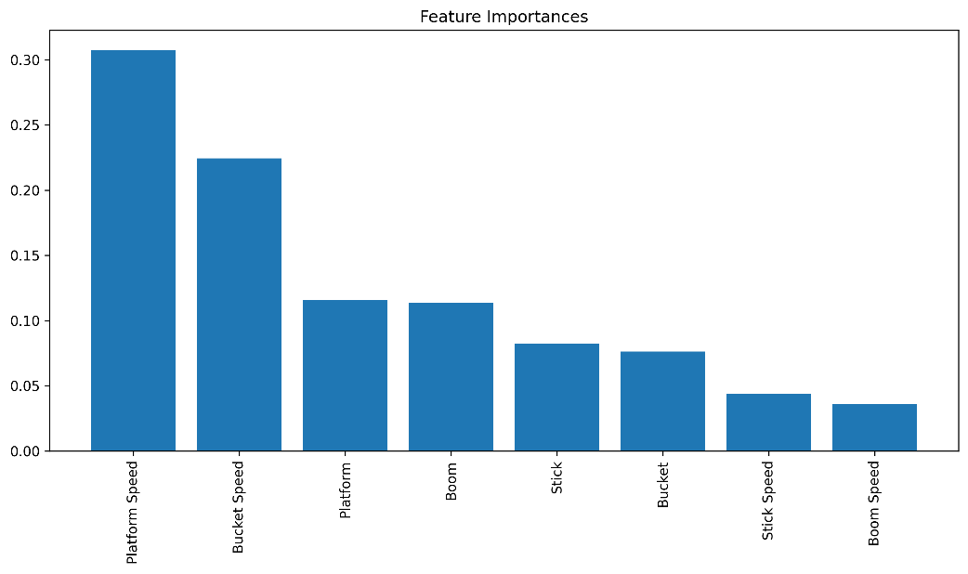

## **Confusion Matrices**

Three scenarios were tested:

1. **Varied Geometry:** Trained on small excavator, tested on larger excavator.
2. **Varied Operator Skill:** Trained on expert operator data, tested on novice operator data.
3. **No Variation (Baseline):** Trained and tested on the same dataset (70%-30% split).

The confusion matrices revealed specific patterns in prediction accuracy:

* Idle activities were predicted with >98% accuracy across all models
* Digging activities were predicted with 91-96% accuracy
* Swinging activities showed more variability (75-85% accuracy)
* Dumping activities were the most challenging to predict (59-70% accuracy)

|  |
| --- |
|  |

# **Discussion**

## **Impact of Equipment Size**

Equipment size had a moderate impact on model performance. When training on small excavators and testing on medium excavators, accuracy decreased by approximately 5%. This suggests that while the fundamental activity patterns remain similar, the magnitude and timing of movements vary with equipment size. The reduced accuracy can be attributed to:

1. Different inertial properties affecting acceleration and deceleration. Larger excavators have different inertia and movement patterns.
2. Different geometric proportions change the relationship between joint angles. Smaller excavations typically move faster relative to their sizes.
3. Different operational capabilities influence how activities are performed. The equipment sizes respond differently to operator inputs.

## **Impact of Operator Skill Level**

Operator skill level also affects the model performance. Models trained on novice operators generalize better to experts (84.6%) than vice versa (85.7%). Expert operators show more consistent patterns within their dataset (94.6% vs. 92.3%). This suggests that expert operators perform activities more consistently and create clearer patterns for the model to learn.

Novice operators likely exhibit:

* 1. More hesitation and corrective movements
  2. Less optimal motion paths
  3. More variable timing between activity phases

## **Limitations and Challenges**

Several limitations should be considered when interpreting these results:

1. The five-category activity classification may oversimplify the complex continuum of excavator operations.
2. The heuristic labelling approach relies on manually defined thresholds that may not generalize across all operational contexts.
3. The 100Hz sampling rate may capture micro-movements that introduce noise rather than signal.
4. The binary novice/expert categorization oversimplifies the continuous nature of skill development.

## **Conclusion**

This research has demonstrated that Random Forest classifiers can effectively recognize excavator activities from kinematic data with high accuracy (92-95%) when tested on the same dataset. However, generalizability across different equipment sizes and operator skill levels remains challenging, with accuracy decreasing by 7-12% in cross-dataset testing.

The two-stage labelling process created reliable activity labels from raw sensor data, with the temporal smoothing algorithm improving label consistency. Some of the key findings include:

* 1. Boom and bucket speeds are the most important predictors of excavator activities
  2. Expert operators produce more consistent and predictable activity patterns
  3. Idle and digging activities are predicted with higher accuracy than swinging and dumping

These findings have implications for the development of context-aware safety and productivity monitoring systems in construction environments.

## **Applications**

The developed activity recognition system enhances construction site safety by providing context-aware identification of equipment activities. By recognizing the specific tasks performed, proximity warning systems can adjust their sensitivity based on the associated risk level. For instance, warnings become more sensitive during high-risk operations such as swinging and less sensitive during lower-risk states like idling. This context awareness also enables dynamic safety zones, where larger clearance areas are enforced during swinging activities, while smaller zones are sufficient during stationary digging operations.

Beyond safety, the activity recognition system supports productivity monitoring and optimization. Automatic identification of activity sequences enables precise measurement of cycle times without manual observation. This makes it easier to spot bottlenecks and improve operations. The system quantifies differences in operational patterns between novice and expert operators, providing objective metrics for training and evaluation. Accurate activity classification also facilitates detailed tracking of equipment utilization, including idle time, productive time, and activity distribution. By correlating activities with fuel consumption, operators can identify more efficient operational patterns and reduce fuel costs.

By identifying specific differences between novice and expert operational patterns, training programs can be customized to address individual skill gaps. The kinematic signatures identified in this research help create realistic, simulation-based training systems that closely match actual equipment behaviours. With real-time feedback from the activity recognition system, operators can quickly learn and adopt more efficient operating habits.

**Recommendations**

Based on the findings and limitations of this study, several directions for future research are recommended:

1. Replace binary skill categorization with continuous measures of expertise based on operational efficiency metrics.
2. Investigate unsupervised methods for discovering natural activity patterns without relying on predefined categories.
3. Conduct extended field studies to validate the approach in diverse operational contexts and with a wider range of equipment and operators.

The developed system represents steps toward context-aware construction equipment monitoring, with potential applications extending beyond excavators to other articulated equipment such as cranes, loaders, and dozers. By providing machines with an understanding of their own activities, this research lays the groundwork for more intelligent, safer, and more efficient construction operations.

# **Appendix**

[Github Repository](https://github.com/Faith-Tangara/Activity-Recognition-of-Excavator-Operations-Using-Machine-Learning)





